Development Journal

for the SCL Website Redesign

Team SCL in Alphabetical Order:

Jonathan Hou

Betsy Li

Vanessa Nguyen

Drake Song

# Understanding the Project Jan. 31st

* 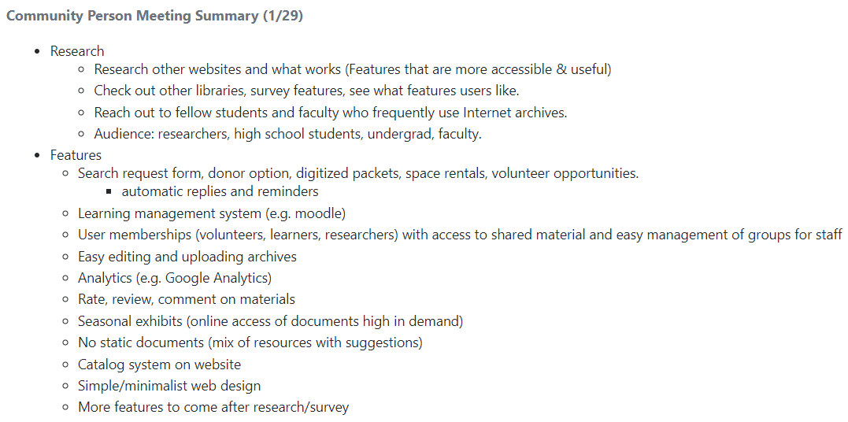Created a summary of our first meeting and emailed it to the SCL staff to review and confirm the content on Jan. 31st.
* In the same email, we updated the SCL staff of what we were currently working on.

“We are researching other libraries' sites (both public and private), reaching out to our friends who frequently utilize Internet archives, and testing out WordPress and other available platforms”

* WordPress site: <https://operationscl.xyz> or <https://operationscl.000webhostapp.com/>, depending on the host server
* Also brought up the topic of visiting their library for a meeting

# SCL’s requests 1 Feb. 6th

* Sent us their material about the scope of the project, users stories, and deliverables they wanted (files found in */Community Person Meeting Notes*)

“This first step is discovery: Some of the key elements are conducting scan of library websites, literature review, and identifying user needs. As first step in conducting library website scans, would be good if group can **develop template with questions/criteria that can be used to review each site** - we are especially interested in **usability and what** **features and functions library websites are offering**.

“For interviews and surveys, ideally questions can be drafted by you and reviewed by SCL staff. We hope that interviews can involve **how folks are using library websites** other than SCL's - and **what is helpful/not helpful**, and can involve having some folks go through **usability exercise with other library websites**. We can also send survey out to selected SCL library members to provide feedback on our current site, and how they hope to use the site in the future.

“If you all can get us **drafts of questions/usability exercise for us to review/approve**; we can help identify people from targeted user groups to approach (i.e. we are working with another Oxy class that is using moodle - and can probably get a student to provide feedback on that platform).”

* SCL mentioned the days we could visit the library (M-F)

## Our response, mostly to the survey request Feb. 12th

* Emailed SCL a **list of questions** regarding **library website usage** and technology usage.
  + Questions about technology usage were there to accommodate the fact that people with different levels of technology usage may have different levels of library website usage as well.
  + We made questions regarding **usability of library websites** and asked users about their searching process on libraries, which **could be turned into a usability exercise** by having users go on library websites to search for something and then report the experience.
  + We tried to quantify answers as much as possible to make future data analysis easier.

How many times did you access or use the internet yesterday?  
On a scale of 1-5, with 1 being not very familiar and 5 being very familiar, how familiar are you with technology?  
How many times did you go onto library websites to look for archives or books this past week?  
How many times did you go onto library websites to learn more about the library and their events this past week?  
What do you expect to see on the home page when you are first sent to a library website?  
What is a feature you would like to see on a library's website that you do not commonly see?  
What is something that bugs you when you're searching online for resources, especially through a library's website?  
On a scale of 1-5, with 1 being not very often and 5 being very often, how often are you confused by the navigation of most library websites?  
What service or feature do you find yourself using the most on a library website?  
What online archive/online library site is your favorite and why?  
What is the most difficult process when looking through online archives?  
On a scale of 1-5, with 1 being not very often and 5 being very often, how often do you filter or specify your searchs when looking through online archives?  
On a scale of 1-5, with 1 being not very accessible and 5 being very accessible, how accessible are the library sites that you use?  
On a scale of 1-5, with 1 being not very helpful and 5 being very helpful, how helpful is the social media presence of a library?  
Would you be deterred from donating to a library if there was a popup for donations on their site?  
When you search for items on a library, what aspect(s) of the items are you searching for? For example, title.

* We started creating a **survey/template that we could use to evaluate library websites** (<https://www.surveymonkey.com/r/BSB9QFM>) based off of the criteria on <http://thevisualcommunicationguy.com/2014/08/27/how-to-evaluate-a-website/> . The survey had problems with accepting multiple responses, so we did website evaluations in .md files (files can be found in */Research*) We created a summary of our library research Feb. 16 (found in */Research/ 02152018 Library Literature Review Summary*).
* We informed SCL that we were doing research on catalog plugins to use for the website. We were looking at the various plugins that were rated highly on pages that ranked catalog plugins and then making a table of their characteristics (found in

*/Research/ Catalog Plugin Research*)

## Our response, mostly to library website evaluation Feb. 14th

* The survey/template previously made had problems with accepting multiple responses, so we did **website evaluations** in .md files (files can be found in */Research*) We created a summary of our library research Feb. 16 (found in */Research/ 02152018 Library Literature Review Summary*).
* We also started a list of **features and functions from library websites** that were listed as having good design (<https://www.pafa.net/selected-libraries-using-wordpress/> and ). This list can be found on Google Sheets through <https://docs.google.com/spreadsheets/d/1NBF2Z_puBE0X7xHZtGy2wGtkR5yoNHw5WqOfsiKSruc/edit?usp=sharing>.

## Justin’s additional input Feb. 23rd

* Justin sent another email Feb. 23rd to inform SCL of our progress on the features and functions list
  + He also asked for their input on our survey questions
* Meanwhile, we were researching on more WordPress plugins to use for the prototype website (files can be found in */Research*). */Research/Library Features Checklist* is a list of features that library websites commonly have, */Research/Library Feature Table* is a table of features and potential plugins to use for them, with the priority of the feature listed.

*/Research/Library Feature Plugin Pros and Cons* is a table for evaluating the different plugins for a feature. We did not input much information into it. We tested out potential plugins on our prototype WordPress site.

# SCL’s requests 2 Feb 23rd

* Told us that what they wanted was something else, and that we should hold off on the survey questions they mentioned earlier

“To begin, I think we were hoping for **more site evaluation in the website review, rather than a listing of features**—and my apologies if I didn’t communicate that adequately in my conversation with you.

“We can do some looking on this end to see if we can find some resources and templates on what such an evaluation might include beyond a list of features

“Since we see the review as a first step that can inform the survey and usability components, suggest we **hold off on those pieces** for a bit until we have a good understanding based on the review of what constitutes an effective website.”

* After Justin’s phone call, he told us that SCL wanted a user experience (UX) audit/competitive analysis and gave us some resources:

<https://www.slideshare.net/somiacx/diy-ux-audit>

<https://uxdesign.cc/ux-audits-and-their-importance-in-the-design-process-55264e55ffd1>

<https://www.toptal.com/designers/ux/product-designer-guide-to-competitive-analysis>

<https://www.nngroup.com/articles/ten-usability-heuristics/>

## Our response Mar. 2nd

* Justin emailed our pilot UX audit for the NYPL (<https://www.nypl.org/>) and our list of user stories and their scenarios. Files can be found in */User Experience Audit/NYPL* and */User Experience Audit/User Stories and Scenarios.*
  + Justin asked for input regarding the quality and depth of our UX audits

## SCL’s response Mar. 7th

* Requested for site evaluation and “in-depth analysis, a features list, and strengths/areas of improvement” about the library websites

The audit is fine as far as it goes, and I think offers a good opportunity for the team to engage more deeply with what worked and didn't on a site while trying to execute a specific task. But it seems to me it doesn't yet provide an actual **evaluation of the site**, though perhaps you were thinking of that as the next step.

Actually, I think some of the resources you shared with the team could be helpful in this regard. In [this article](https://www.toptal.com/designers/ux/product-designer-guide-to-competitive-analysis) you sent, it says an analysis report will include annotated screen shots (like the ones provided by the team), but also an **in-depth analysis, a features list, and strengths/areas of improvement, and eventually an analysis matrix based on 3-5 such website scans**. I think more in-depth analysis reporting along these lines would be helpful.

Another possible resource for summarizing the results of a scan is this [article on journey mapping](https://www.nngroup.com/articles/customer-journey-mapping/), which includes a format for organizing findings and observations.

* We already created a **features list** Feb. 14th

## Our response Mar. 12nd

* Justin sent an emailing stating that a summary/website evaluation would be best after we finish all of the UX audits for all of the user stories/scenarios.
* Also informed them of our prototype WordPress site and whether they would like it.

## SCL’s response Mar. 13th

* They informed us that they would like to receive the prototype WordPress site.

## Our response Mar. 27th

* Justin informed SCL that we finished our NYPL UX audit; we also created a pros/cons summary of NYPL as our **website evaluation** and **strength/areas of improvement**.
* Mar. 30th SCL informed us that they would be busy.

## Our response Apr. 10th

* Justin sent our UX audits and summaries for the LAPL (<https://www.lapl.org/>) and Somers Library (<https://somerslibrary.org/>). These files can be found under */Research*
* We switched gears and focused on implementing features on our prototype WordPress site.

Need to address website plugins and layout; how the UX audits informed our decisions.